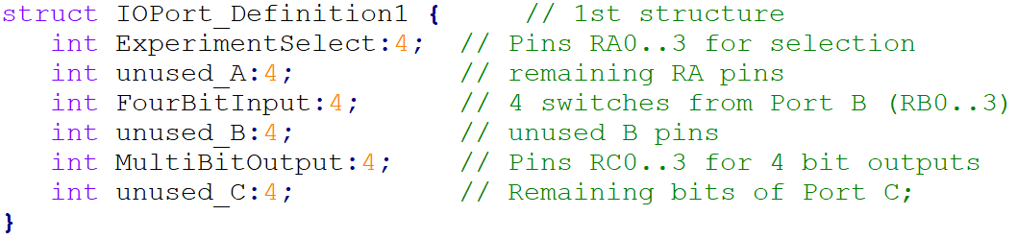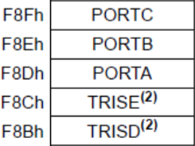

bits

First Structure:

4

4

4

4

4

4

Second Structure:

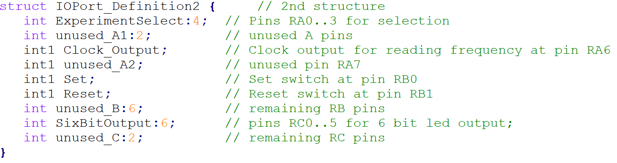

6

2

bits

6

1

1

2

1

1

4

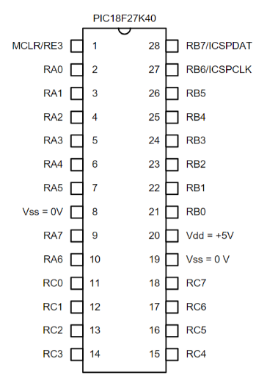

Example of second Structure:



Example of First Structure:

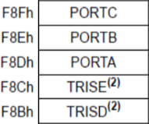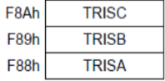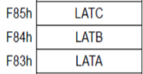

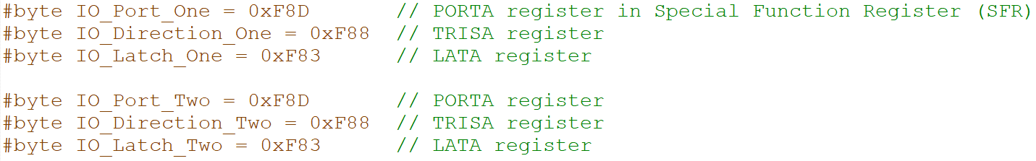



1

2

END

3



1

2

33

END



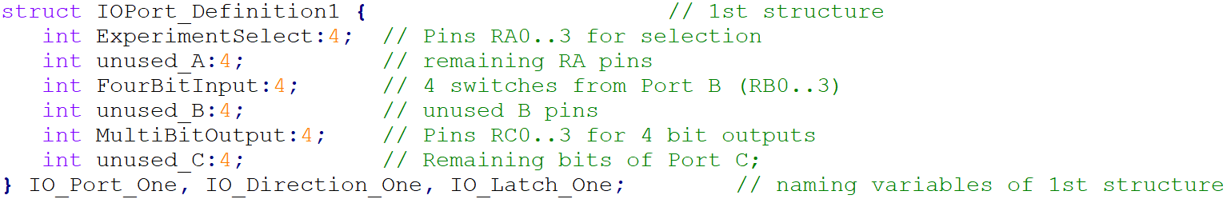

1

2

END

3

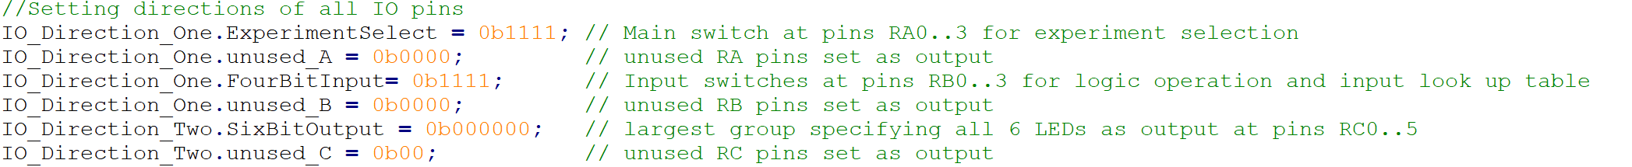

Pins RA0, RA1, RA2, RA3

1

2

END

3

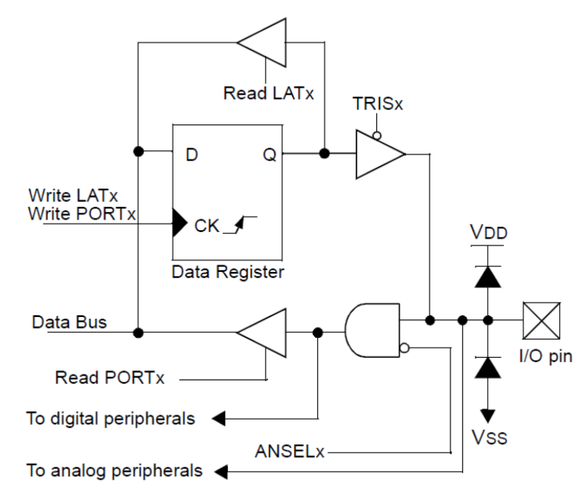

**OUTPUT:**

**INPUT:**

**= 0b1**

**= 0b0**

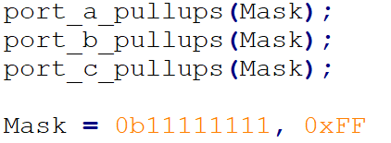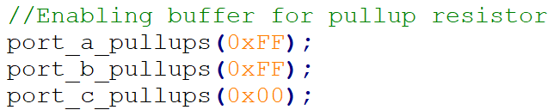g

**=>**

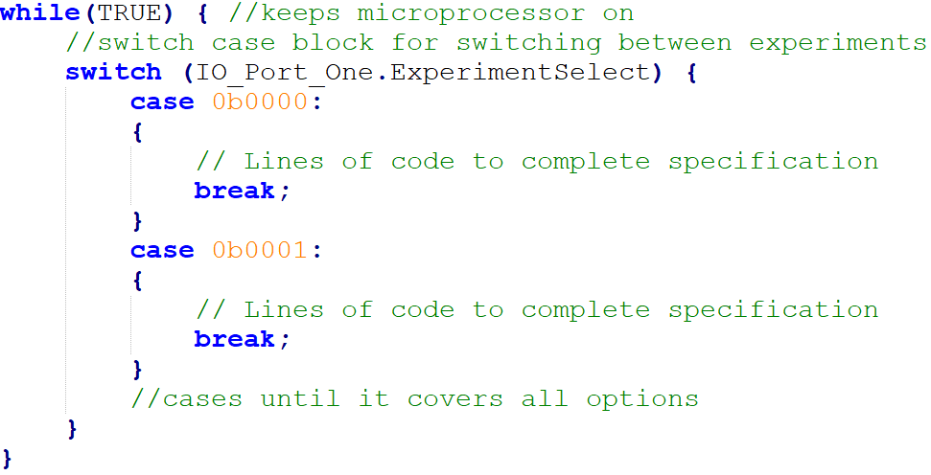

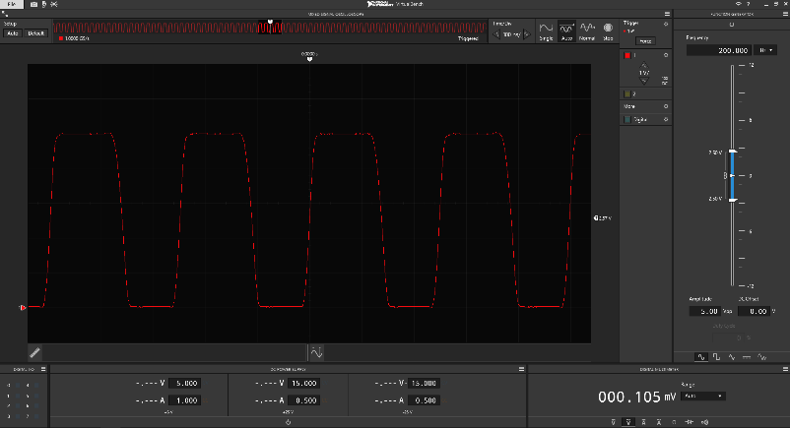

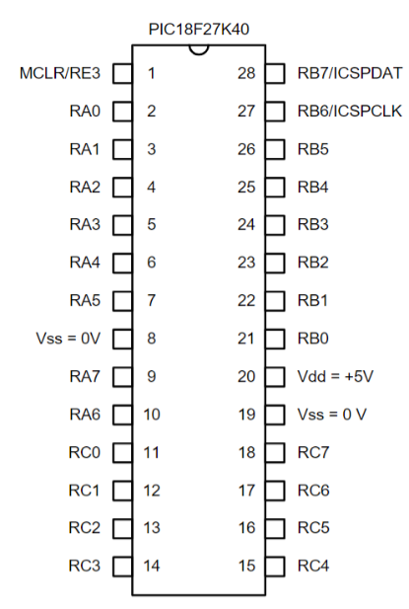

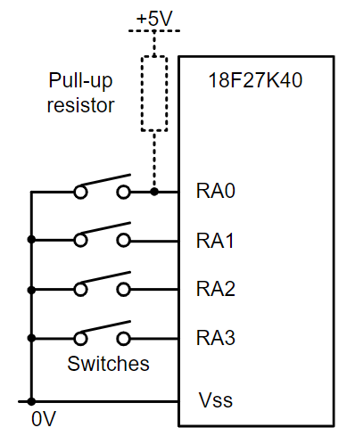

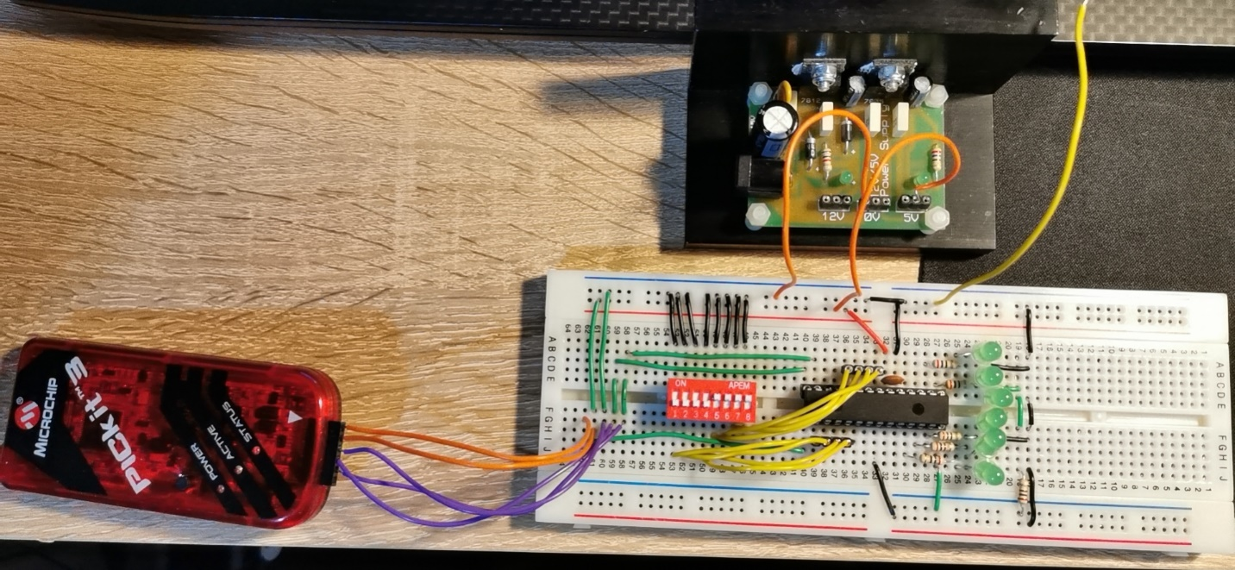

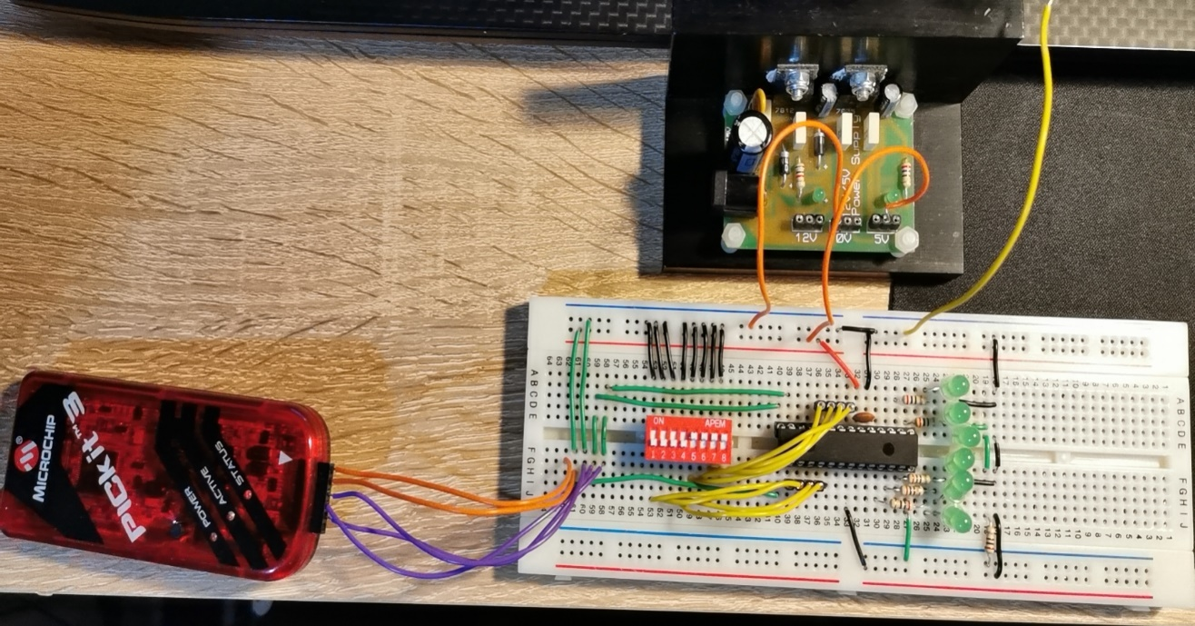

0000 | Clock microprocessor is running at 16MHz, pin RA6 produces 4 MHz.

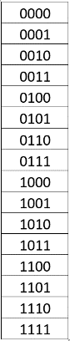

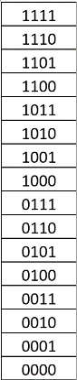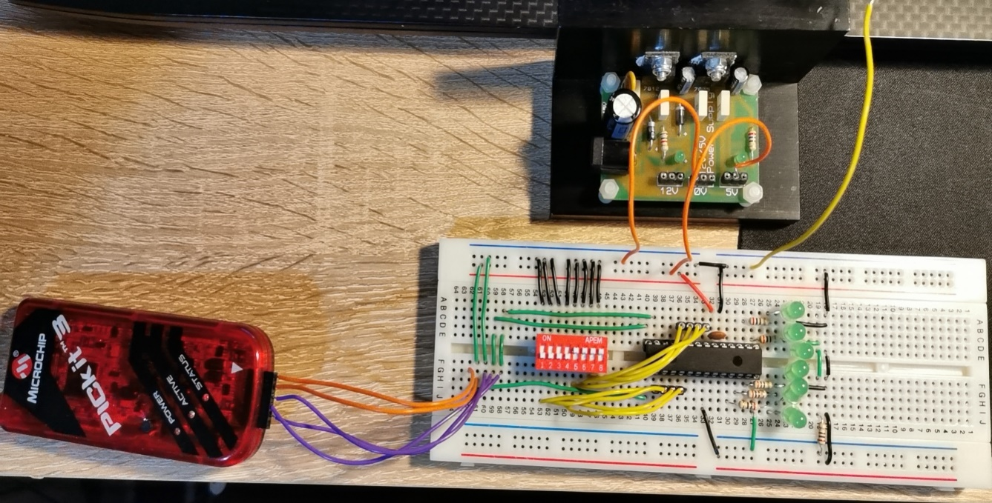

0100 | 4-bit pure-binary down-counter

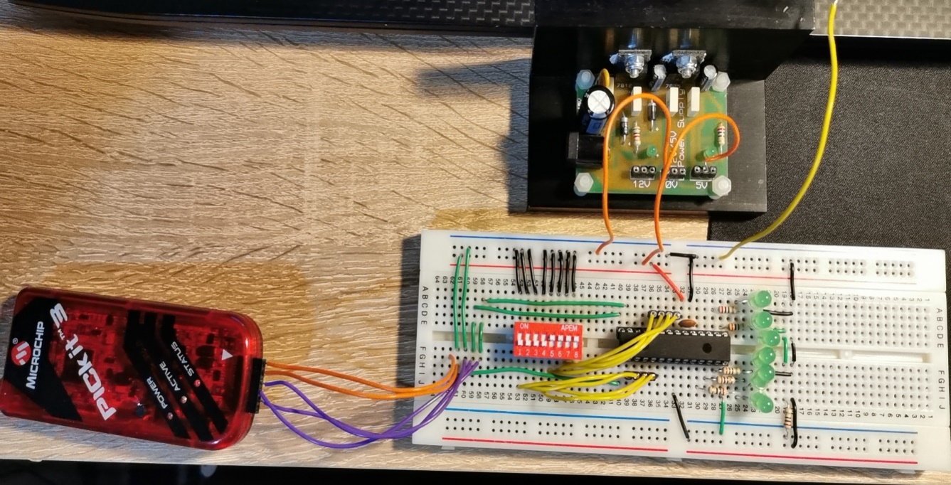

0011 | 4-bit pure-binary up-counter

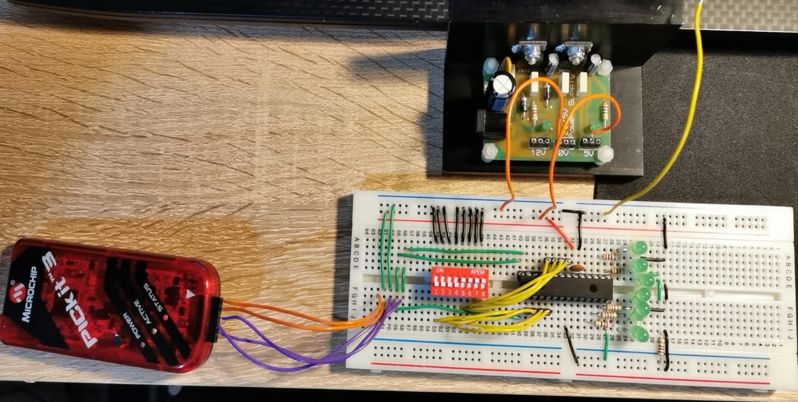

0001 | T-type flip flop in toggle mode. Pin RC0 produces 1Hz.

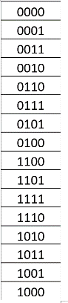

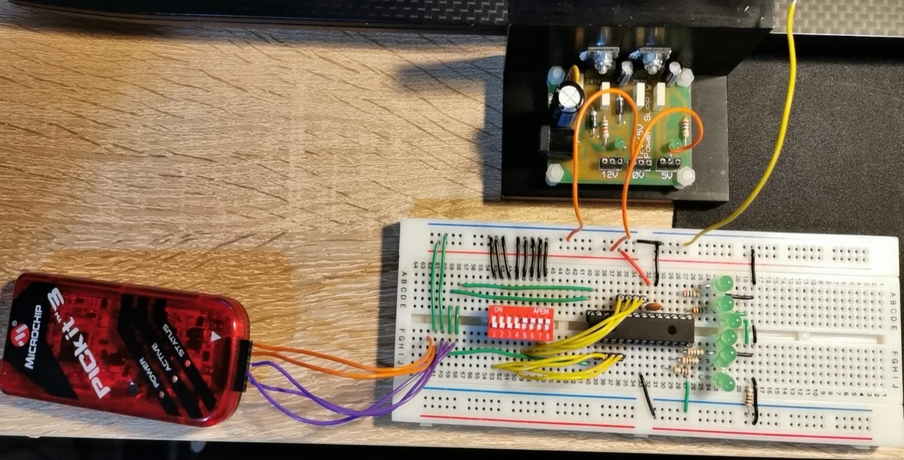

0111| bitwise AND operation

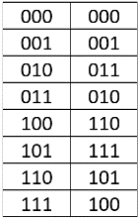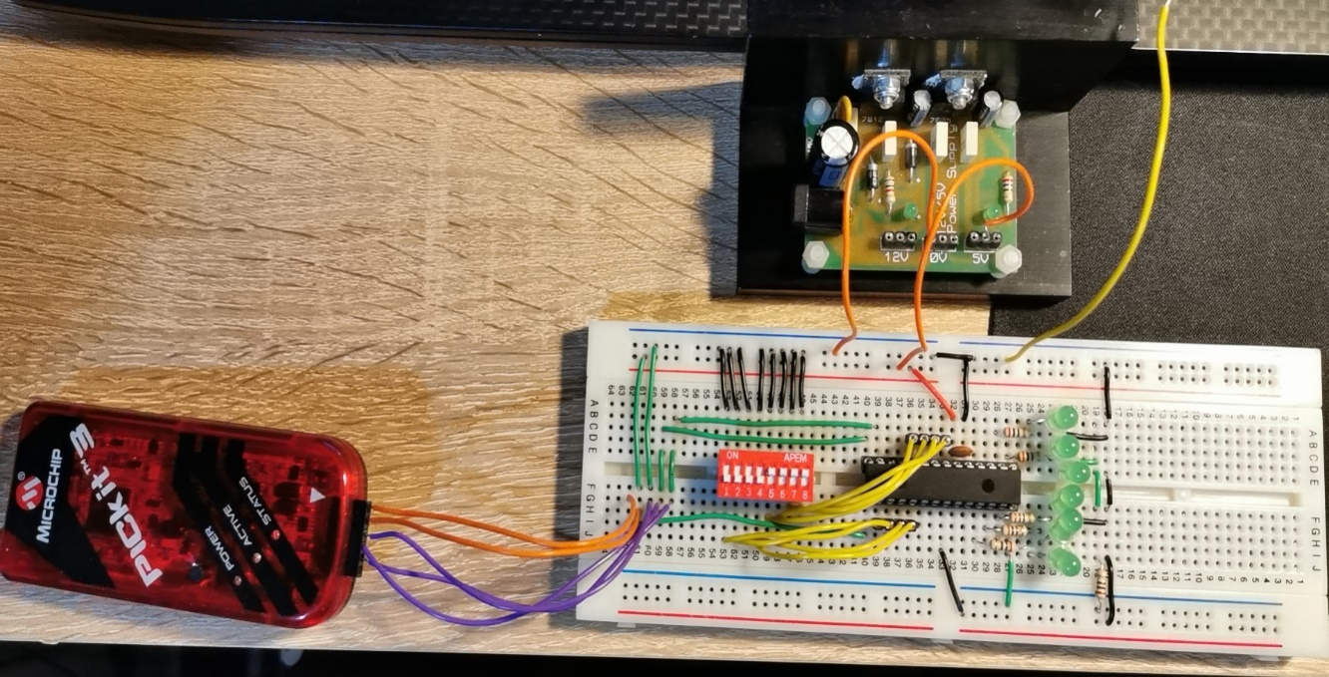

0110 | 3-bit pure-binary up-counter with 3-bit Gray-code up-counter



0101 | 4-bit Gray-code up-counter using look-up table



1000 | bitwise OR operation



1001 | bitwise NOT operation



1001 | bitwise Exclusive-OR operation

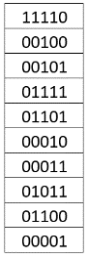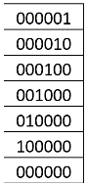



1101 | Lab 1 FSM using Look up Table



1100 | Input Look-up Table



1011 | set-reset flip-flop synthesis



1110 and 1111 | Appropriate action, turn every light off